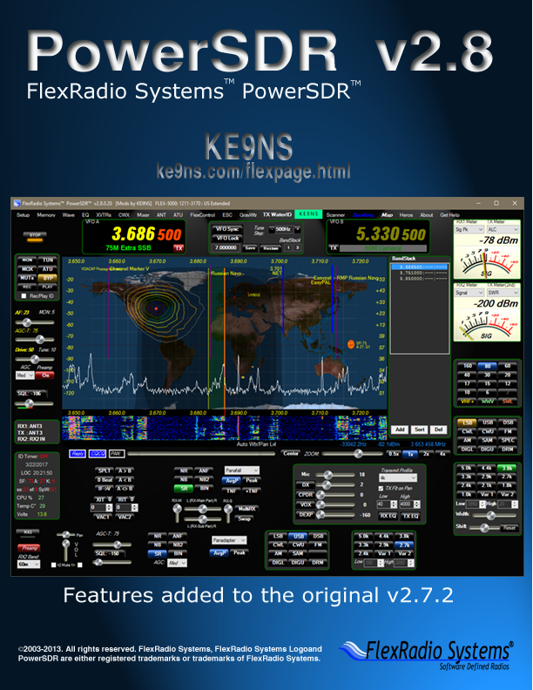

V2.8.0.92

**Highlights of v2.8.0.xx**- DX Spotting to Panadapter, and clickable World Map (with spots) in the Panadapter display area.  
- SWL Bands, and SWL Spotting to Panadapter (with searchable listings panel)  
- BandStack memory (clickable) list screen (with ADD, SORT, DEL functions)  
- Scanner: Memory, Frequency, SWR Plotting & Logging, Memory Scheduler with MP3 recorder   
- Voice Keyer, Quick record as MP3, ID Timer, Space Weather, VOACAP, Beacon Scanner, PowerMate   
- Transmit Text & images to other Radio Operators that have SDR waterfalls (TX WaterID)  
- Larger VFO’s , New Meter types (and meter options), Color Gradient Panadapter, new ke9ns skin options  
- LoTW log checking for DXCC, WAS, and Dups  
 **Basic Procedure for New “Fresh” Installation:**  
- PowerSDR v2.7.2 can coexist with v2.8.0 (it runs from a separate Database folder and program folder)   
- Run Windows 10 x64. If you have Windows 7 make sure to install Service Pack 1 (SP1) before anything else  
- Open Window Device Manger and make sure your IEEE 1394 FireWire Card is working (Flex-3000 & Flex-5000)  
- Download the FULL Installer “PowerSDR ke9ns v2.8” from ke9ns.com/flexpage.html (Orange Button)  
- Install v2.8. You should now have 2 additional icons on your desktop (PowerSDR v2.8.0 and FlexRadio.exe)  
- FlexRadio.exe is to check on the FireWire Connection (don’t touch anything in here)  
- Launch PowerSDR v2.8.0 (right click on Icon and click on “Run as Administrator”  
- Open “Spotter” window and type in (lower right side) Lat & Long & Call Sign of your Station  
- Click on TIME SYNC button (Spotter window) to make sure your PC clock is synced to NIST  
- Set the Mouse wheel Tune Step (top center of PowerSDR console) to something more suitable (I use 500hz steps)  
- Configure your Transmit profile based on your Microphone & voice, then Save the profile under a new name.  
- Double Click on Space Weather (lower left of PowerSDR console)  
- Any future updates to PowerSDR: Download / Install from the Incremental Installer (Green Button) only.  
  
**“Optional Extas” Procedure after Installation:**   
- Download/Install **vspMgr** (by k5FR) to create multiple virtual serial port pairs for CAT command  
- Download/Install **DDUtil** (by K5FR) to multiplex ½ of each virtual serial port pair to allow other PC programs to all communicate with PowerSDR at virtually the same time (i.e. Logging software, digital mode programs)  
- Download/Install **FLDIGI, FREEDV, SIGMIRA, DIGIPAN, CW SKIMMER, HRD, MULTIPSK** if you want to try digital modes of HF communication CW,RTTY,PSK, etc.  
- Download/Install **WSJT-X** if you want to try FT8, JT9, WSPR   
- Add an external **AM broadcast band filter** (to reduce the Noise Floor of the radio)  
- Use built in Windows “**Remote Desktop Operation**” program (mstsc.exe) for full 2way audio remote operation  
- If you’re up to it, follow guidelines on my ke9ns.com/flexpage.html webpage for turning off CPU hogging Windows tasks that might occur while you in the middle of using PowerSDR and cause expected high CPU numbers.  
 **Knobs for VFO control (and other PowerSDR features):**   
- **Mouse Wheel**: VFO follows the Tune Step rate. (Top center of the main PowerSDR console). Right Click inside Panadapter to enable Cross-hair feature, then Left Click inside Panadapter to jump Frequency directly to Cross-hair.  
*NOTE: You will probably want a Wheel that has “detents” as opposed to a “free” mouse wheel.*- **PowerMate** Knob: VFO can follow alternate Tune Step rate from your Mouse Wheel. (setup->General->User Interface). Button push cycles through 2 preset tune step rates.  
- **FlexControl** Knob and buttons: VFO can follow alternate Tune Step rate (setup->General->User Interface)  
in addition to other programmable button functions. (FlexControl menu item on main PowerSDR console)  
- **SpaceNavigator** Knob and buttons: VFO follows Tune Step rate. Tilting knob up/dwn, left/right allows for Panadapter flight or filter changes. (setup->Navigation)  
- **DJ Console** (DH1TW): For Hercules MP3e2, MP3LE, and Mk2 models. VFO and many other features supported. (Setup->General->User Interface)

Summary of features

**Main PowerSDR Console Updates:**- Much Larger VFO Frequency readouts  
- Color rings around functional groups  
- Active VFO “Ring” Glows RED during Transmit  
- SWL Band buttons (each with their own Band Stack)  
- Space weather panel (requires internet)  
- Local weather Fly-Out window (for N.A. only and requires internet and PowerSDR needs to be open large enough)  
- Temp and volts panel  
- VFO LOCK button toggles between VFOA, VFOA/B, and VFOB  
- SPLT (right click to toggle between +/- 5khz split in SSB and +/- 1khz split in CW  
- XFC (Setup->Display->Split Listen) Listen to the TX freq when in Split mode  
- ID TIMER (Pop Up window, Voice, CW, or WaterID options)  
- Audio / Monitor Sliders (click on AF or MON to select)  
- Drive / Tune sliders (click on Drive or Tune to select)  
- Right Click on Drive or Tune to Toggle LOCK  
- Right Click on MUT for MUTs (to mute just speakers)  
- Right Click on TUN for TUNp (Pulser tune mode: Setup->Transmit)  
- Click on MON to toggle between MONps (post-processed), MONpr (pre-processed), and off  
- Rec / Play: Multiple Quick audio files, and MP3 recording output  
- REC/PLAY ID: Record and play your own TX audio instead of the RX audio  
- REPLY, CQCQ buttons for voice keyer operation (see Wave)  
- Mute Checkbox for Muting just RX1 or RX2 audio  
- Click AVG button to toggle between AvgP (just Pan), or AvgB (both Pan and Waterfall)  
- Right click on many buttons to go directly to the setup menu  
- Enable VAC2 for radios without a second receiver.  
- Virtual Mechanical VFO Dials (when PowerSDR is opened large enough to fit them between the VFO panels)  
- ke9ns skins (3 versions) with new sliders  
- AM Mode: Drag RX Bandpass across Carrier point to switch RX to SSB, while still allowing TX in AM mode  
- AM Mode: SSB with Carrier (AM-L/AM-U, SAM-L/SAM-U)  
- BandText (right Click on the VFOA bandtext to Toggle BandText in Panadapter area.  
- Camera icon (lower left of Panadapter) Left Click to take a JPG screen shot, Right Click to Open Folder containing screen shots. (Setup->General->User Interface->Full Console checkbox will allow you to take full console screen shots)  
  
**Band Stack Features:**- Band Stack Indicators on Top center of PowerSDR console (Current #, Total #)  
- Click on Band Stack Indicators to open Pop-Out Stand-Alone **Band Stack window**  
- Right Click on Band Stack Indicators to open Fly-Out window in the Panadapter/waterfall display (right side)  
- **Band Stack Add, Sort, Delete buttons.**  
- Left click on Band Stack entry to LOCK: freq, mode, filter from changing

**TX/RX Meters:**  
- Analog sweep needle Meter(s) (dark and Light versions)  
- Signal Peak / hold feature  
- **Enable2nd Meter for 2nd** TX Meter function  
- **Combo bar graph 2nd Meter** (4 functions for 2nd meter)  
- Move 2nd Meter up under 1st meter.  
- Click on Top meter to toggle between Meter types (6 types)  
- **Live MIC meter** movement active while in RX mode (2nd meter only)

**Display Panadapter and Waterfall areas:**- BandText (right Click on the VFOA bandtext to Toggle BandText in Panadapter area.  
- Color Gradient Panadapter Fill (Setup->Appearance->Display->Pan Fill Gradient)  
- Add Panafall 8020 Display Mode: 80% Panadapter, 20% waterfall.  
- RX1 and RX2 can both have PanaFall modes together at same time (both with DX,SWR, Memory Spotting)  
- Hit ALT + M key when focused on the Spectrum (Panadapter) screen to add memory from Panadapter screen  
- Semi-Auto Waterfall brightness & Panadapter level adjustment (Left & Right Click on “Auto Wtr/Pan Lvl” button)  
- **Fully automatic Waterfall & Panadapter levels** (Setup->Display->auto wtr/pan checkbox)  
- Auto Grid and water base level sliders in Setup->Display  
- Waterfall moves (left – right) as you move frequency (left – right). Black areas appear where there is no history.  
- VFOA slider (Lock the Panadapter screen, and unlock Bandpass window) (click on the PAN: button)  
- Amplify RX signals (click on the Zoom button)  
- Magnify RX signals (Right click on the Zoom button)  
- DX, SWL, and Memory Station markers appear in Spectrum   
- SWR plots appear in Spectrum  
- GrayWtr button: Left Click = Toggles Gray or Color waterfall option, Right Click Toggles (Setup->Display->Fill Pan)  
- Continuum Display mode (right click on Continuum to toggle recording of .CSV file)  
 **World Map mode:**- World map appears in the Spectrum (Panadapter) part of the screen  
- Special Spectrum (Panadapter) 80% and Waterfall 20%  
- Display DX Spots directly onto map (either Country or Call)(clickable to go to freq, mode)  
- Beam Headings on each mapped DX spot (including Moon, and ISS)  
- **Grayline** plot (with dusk area) (Setup->Appearance->Display->GrayLine Color->Alpha)  
- **Sun, Moon, ISS plots** (ISS requires Internet connection)  
- Shift Key to show LAT / LONG grid, and DX “Spotters”  
 **“Spotter” window Features (DX related):**- **DX Cluster** spotting (including reverse beacon clusters)  
- Filters: Include N.A. or Exclude N.A, Spot CW, Digital, Phone, Beacons  
- Automatic parsing of Spotter information (including Country, mode, Split, beam heading)  
- **LoTW** Log Book of The World Check for DXCC, WAS, and Dups.  
- Post contacts to the DX cluster (Callout)  
- **DX Beam headings** (based on your Lat & Long station inputs)  
- **Rotor Control** by clicking on beam heading (using DDUtil)  
- **QRZ lookup** (from PowerSDR) of DX stations (right clicking on spots)  
- DX stations appear in Spectrum (Panadapter) by frequency (and Clickable)  
- DX stations plotted on World Map (Clickable)

**“Spotter” window Features (other):**- Sun location on world map (including space weather)  
- Moon location on world map (including AZ,EL and AZ rotor control)  
- ISS location on world map (including AZ,EL, and AZ rotor control)  
- Time Sync function via Internet (for setting your PC Time clock. Required for NCDXF Beacons, JT65, FT8 modes)  
- Time Sync function via WWV HF radio (requires a strong stable signal to decode)  
- NCDXF/IARU Beacon Scanner (Fast: Scan all 5 stations/10 seconds, Slow: Scan all stations on each Band)  
- Memories show up in Spectrum (Panadapter) window.  
- VOACAP Plots for all HF bands (requires Internet for Sun Spot numbers).

**“Spotter” window Features (SWL related):**- SWL Spotting (including Utility, Military, Government, Pirate, digital)  
- SWL main list provided by eibispace.de  
- Second SWL file provide by ke9ns and includes Government, and Utility stations.  
- SWL Searchable List Window (search any part of the station name)  
- Google lookup (from PowerSDR) of SWL station names  
- SWL Stations appear in Spectrum (Panadapter) by frequency (and Clickable)

**TX WaterID (Waterfall Images) Updates:**- Transmit images that can be viewed by other SDR radios with Waterfall’s  
- Transmit simple Text (like your Call Sign) or Graphic images (as wide as your TX bandwidth)  
- Best viewed with the AVG button set to AvgP, and not zoomed out too much.  
- Requires the Receiving SDR to have a good signal from your station.  
- Transmit images width set to your radios current TX bandwidth (Setup->Transmit->Wider TXWaterID)

**“Scanner” window Features:**- Memory Scanner (type in all or part of a Group name) (with Speed control)  
- Memories in window are clickable  
- Scan Band Stack  
- Custom Frequency scan list  
- Low to High Frequency Scanner (with Step rate, and speed)  
- Pause on Squelch Break (pause time or stop)  
- SWR Plotter, Logger (saves up to 5 SWR plots per band, per ant)  
- SWR Plots displayed on Panadapter window (up to 5 at one time in in Panadapter Display mode)  
- SWR Saved in a file for recall at any time  
 **Memory window Updates:**- Scheduler: Go to Memory on a time Schedule.  
- Scheduler & Recorder: Go to Memory on a time Schedule and record an MP3 audio file of the event.  
- Schedule Weekly, Monthly, Start Time (Local, or UTC), then set duration in minutes  
- Hyperlink capability added to the “Comments” Field (right click on URL in Comments field to open web page)  
- Use Group names for Scanner window  
- Hit ALT + M key when focused on the Spectrum (Panadapter) screen to add memory from Panadapter screen

**Wave window Updates:**- Multiple QuickAudio files with coded file names (in their own folder).  
- MP3 Quickaudio files (in their own folder). Makes it easy to send to your friends.  
- Voice keyer file creation: ID Timer voice or cw ID audio files, or Reply and CQ audio files  
- Click on voice keyer file button, record your voice, and click again to save. Done.  
 **Setup Features:**- Software update check   
- Receive Only But Toggle of PTT toggles Start/Stop of Receiver.  
- PTT Hang timer (mSec of extra time before releasing MIC)  
- Time-out Timer (General->Hardware Config), shuts down TX if timer exceeded.  
- Band Text update button. No need to reset the database. (General->Options)  
- DJ Console (DH1TW) (General->User Interface)  
- HTTP remote of Display or full console screen “server” (General->User Interface)  
- N1MM Spectrum output (General->User Interface)  
- PowerMate controller with optional alternate Tune rates from the mouse wheel (General->User Interface)  
- FlexControl optional alternate Tune rate from the mouse wheel (General->User Interface)  
- Transmit Phase Invert (setup->Transmit)  
- 2nd Meter on/off and move below 1st meter (setup->Transmit)  
- CAT Rotor Control Port (setup->Cat Control)  
- Bold or Outline VFO fonts and ring color (Appearance->General)  
- Alternate Meter background and pointers (Appearance->Meter)  
- Drive Limit setpoint (Setup->Transmit->Drive Max)

End of Summary

**“Spotter” window (top of PSDR console screen):**  
- **DX Cluster** (from a list of up to 10 URL address’s as URL:port )   
- Automatic parsing of Cluster information to deduce Mode, Split  
- Determine DX Country and location (based on included dxloc.txt file)  
- Automatically Manage Age of DX spots and update the spotter, checking for dups, etc.  
- Automatically compute Antenna rotor angle of DX station relative to your station lat & long  
- LoTW Log download/update for DXCC, WAS, and DUP checking.  
  
- Left Click on any DX spotter line to go directly to Freq, Mode, Split of DX station  
- Left Click on any DX spotter line “rotor angle°”, and you also send an Antenna rotate command to DDUtil to move your Antenna. (see rotor setup example at ke9ns.com/flexpage.html)  
- Right Click on DX spotter line to open up QRZ.com page for DX spot

**LoTW (ARRL Log Book of The World)**

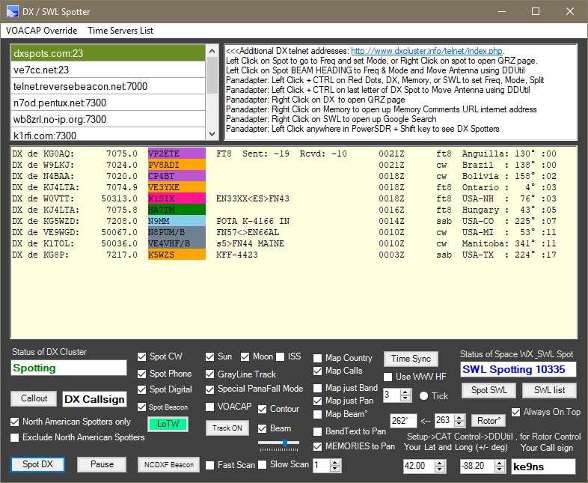

If you do NOT have an LoTW account, SIGN UP AT: <http://www.arrl.org/quick-start>

Yes its overly complicated, but you only need to do it one time!

1) You must have **your Callsign** entered in the box in the bottom Right corner

2) Right click on the Callsign box and enter in your **LoTW password**.

This is the password that you use to login to: <https://lotw.arrl.org/lotw/login>

-----------------------------------------------

**- Left Click** on LoTW button = Toggle On/Off:

PowerSDR will check to see if you have a “**LoTW_LOG.adi”** file, and “**FCCDATA.dat”** file in your database folder.

Files YES= Open/Read “**LoTW_LOG.adi”** and “**FCCDATA.dat”** files, and start checking DX Spots for Dups, DXCC Countries list, and US States.

Files NO= PowerSDR will go to ARRL and download your **FULL** LoTW Log file. (**This may take a few minutes to download**) If you don’t have a “**FCCDATA.dat”** file, PowerSDR will attempt to find EN.dat and convert it to “**FCCDATA.dat”**

- **Right Click** on LoTW button = incremental Log file update:

PowerSDR will go to ARRL and download incremental QSO/QSL updates to your LoTW Log file (based on the Date of the Last Update). This requires only a few seconds to update.

**LoTW** when running.

**LoTW** when downloading a LoTW Log QSO/QSLfile

**LoTW** when a fault occured.

**Color Coded DX Spots**:

Green: You have this DX Station confirmed on this Band (dont need this Dx Station)

LightGreen: You have this DX Station confirmed on some other Band

Yellow: You have this DX station confirmed on some other band, and some other station already confirmed on this band (dont need this DX Station)

Orange: You have this DXCC country confirmed on this Band (you dont need this DX Station

LightPurple: You have this DXCC country CONFIRMED on some other Band (you WANT this DX Station)

Purple: You WANT this DXCC country (you WANT this DX Station)

DeepPink: You have worked this DX Station on this Band (But they have not confirmed)

Pink: You have worked DX Station on some other Band (But they have not confirmed)

LightBlue: You have this US State confirmed on some other band (you WANT this DX Station)

Blue: You WANT this US State (You Want this DX Station).

Gray: Beacon Station

Post DX spot contact via the Spotter "Callout" button (i.e. Post your contact to the Dx cluster directly from PowerSDR) Two ways to Post a contact: 1) Make a contact, type in the contacts Callsign in the "DX Callsign" box and hit Post, then confirm YES to the pop-up message box. 2) Select a DX spot from the DX Spotters list, make contact, then hit Post (leave the DX Callsign box alone), it will use the highlighted DX contact as the callsign. Within a few seconds, you will see your post appear at the top of the DX Spotters window. Note: The DX Cluster must be active and running in order to Post to the Cluster. Also, your posting under your Callsign as the Spotter.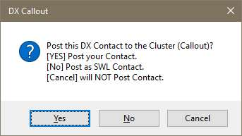

- **DX spots appear as Markers along the Panadapter window** (with **Green lines**)  
- **Left Click then CTRL** on a DX Spot Callsign (in Panadapter) will set Radio to that DX stations Frequency, Mode, Split, and **Highlight** that stations Line in the DX spotter window for easy identification in the spotter window.  
- **Left Click then CTRL on the last letter** of the DX Spot Callsign will not only set the Radio, but send a Rotor Antenna move command.  
- **Right Click** on a DX spot Callsign (in Panadapter) to open up QRZ.com page  
- **Shift key** (while PSDR is in Focus) switches DX spots to DX Spotters, and brings up a Lat & Long grid.  
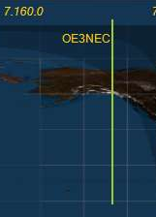

- **Memory to Pan** (checkbox) places your memory list onto the Panadapter (with **Blue lines**)  
- **Left Click** on **Memory** in panadater, hit CTRL key, to go to that freq, mode, split, filters, etc.  
- **Right Click** on **Memory** to open up a URL Address (web page) that you place in the Memory Comments field. (example: http://www.vk3evl.com/index.php?option=com_content&view=article&id=57&Itemid=62)  
The above example would take you to the Easypal download web page.  
 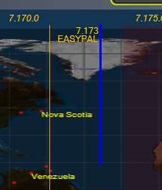

- **Spot SWL** places ShortWave Stations (described in detail down below) onto the Panadapter (with **Purple lines**)  
- **Left Click** on **SWL Spot** in panadater, hit CTRL key, to go to that freq, mode.   
- **Right Click** on **SWL Spot** to Google Search the Name of the ShortWave Station.  
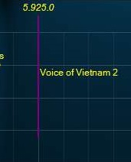

- **World Map** (**Equirectangular projection embedded into PowerSDR) with special 80/20% Panafall mode.   
- True Sun position (based on time and date) including solar weather data.  
- True Moon position (based on time and date) including Beam heading and Elevation angle.  
- True ISS (International Space Station) using Internet data, including Beam heading and Elevation angle. Along with dots showing the ISS positon over the next 20 min.  
- True Grayline (with Sunset and Dusk areas): (based on time and date). Right click on CENTER button to adjust color and transparency.  
- DX Spots appear on World Map as Red Dots in their correct locations (options to show country or Callsign).  
- Left Click (to focus PSDR), then hit CTRL over any Red Dot to go directly to DX spot freq, mode, split  
- Option to map spots on map for your current Band, or current Pan**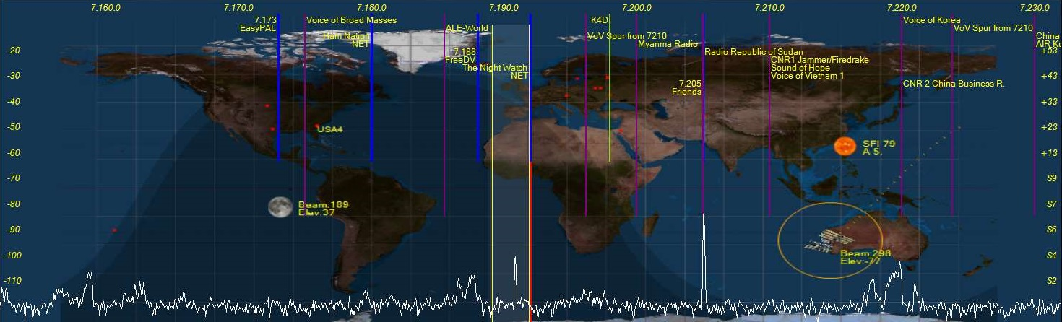

**- VOACAP propagation mapping. Automatically compute propagation conditions, based on current solar weather data, using the Effective SunSpot#. Map changes based on power level slider (up to 1500w). Default is 35’ Dipole or optional 35’ 3 ele Yagi antenna checkbox.   
- Display Propagation map as dots (the larger the dot the stronger the signal a person under the dot would receive from you. (Gray = S1-S2, Orange=S3-S4, Yellow=S5-S6, Green=S7-S8, Blue = S9-S9+)  
- Display Propagation map as Contours (Gray = S1-S2, Orange=S3-S4, Yellow=S5-S6, Green=S7-S8, Blue = S9-S9+)**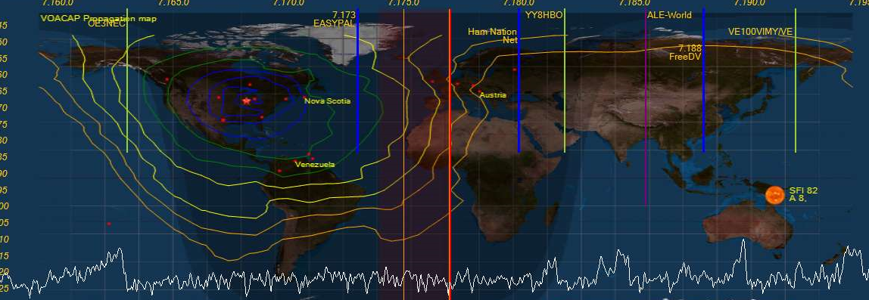

**-SWL Spotting with searchable listing window. SWL.csv file included (from eibispace.de) contains current list of SWL stations. SWL2.csv contains additional “Utility” SWL stations.  
- SWL_Search button added to PowerSDR Console screen  
- SWL stations appear on Panadapter as Purple Lines  
- SWL stations checked for Day and Time of operation  
- SWL searchable listing has an update button to rescan for those SWL stations currently on the air.  
- Only SWL stations currently on the air appear in the SWL search list and on the Panadapter.  
- Many Utility Stations also appear on the list: ALE, VOLMET, HFDL, DRM, STANAG, DSC, NAVTEX**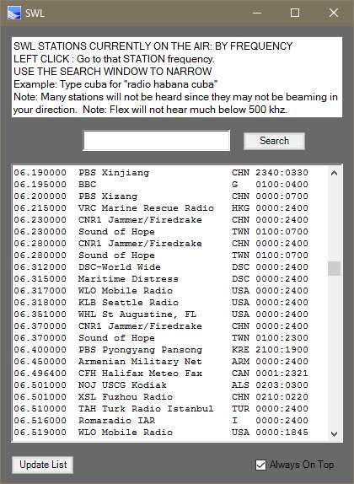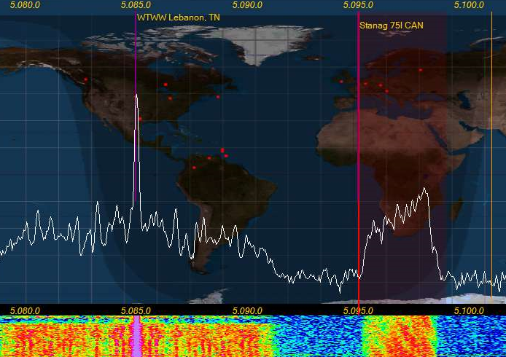

**- NIST Time Sync feature. Internet based or WWV HF radio based decoder.   
NOTE: PSDR must be launched in ADMIN mode to allow PSDR to update your PC time clock.  
- Internet: UnCheck the WWV box, Click the “Time Sync” button. Internet time servers can be jammed up, so you may need to try multiple times to get a response.  
- WWV HF: Check the WWV box, select the station from the box below (1=2.5mhz, 2=5mhz, 3=10mhz,4=15mhz). PowerSDR will narrow up and lock onto the WWV 100hz sub-carrier, which is BCD pulse width modulated. This can take up to 2 minutes to fully decode the Time and Date (because you might have just missed the start of the minute)   
NOTE: Even though the main carrier maybe stable at S9+, being an AM signal, the audio including the sub-carrier is always 1/4th the power of the carrier signal, and so subject to severe fading.**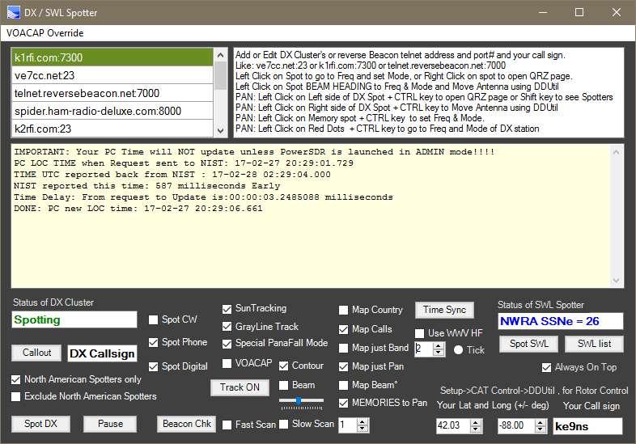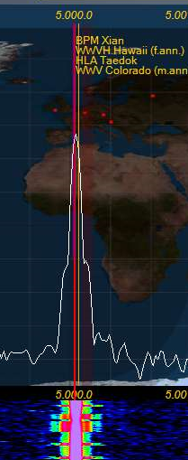

**- NCDXF/IARU Beacon scanner. Beacon Stations setup around the world time synced to allow reception reports without technically needing to decode the CW signal.  
- Fast mode jumps across all 5 stations every 10 seconds.   
- Slow mode stays on 1 selected beacon frequency and runs a full cycle listening for all stations 1 time. NOTE: World Map must be running)  
- Reports the Signal strength and noise floor dBm values on the DX spotter window and by color on the map.**

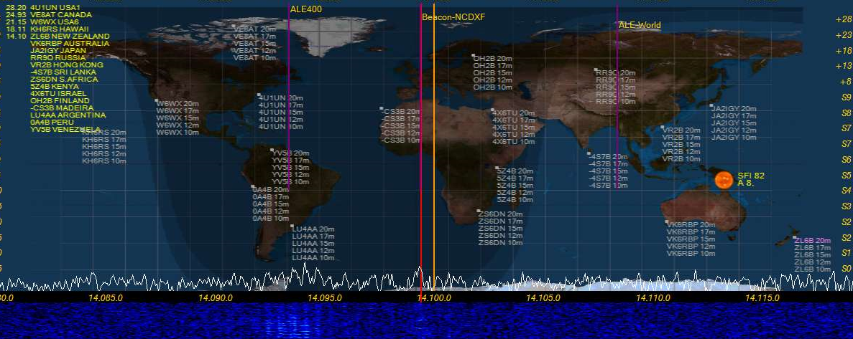

**“Wave” button** **(top of PSDR console screen):**  
- **QuickAudio Save Folder**. Creates a folder and increments the file name to automatically keep multiple audio files. File name increments after every creation.  
- **QuickAudio MP3**. Creates an MP3 file of all QuickAudio files and put it in a folder for just MP3 files  
- **MP3 Folder button**. Separate folder just for MP3 files  
- **Special QuickAudio “Record” Buttons**: Click 1 of the 4 buttons, Speak into the Mic to make your recording, Click the same button again to end the recoding and save the file under a predetermined name permanently. If you click the same button over again, you will create a new recording (losing the last recording you made)  
1) **Voice ID,** make a recording of you saying your callsign. Example: “Ke9ns for ID” . To be played if your 10 min ID Timer is set to voice ID.  
2) **CW ID,** launch the CWX panel and use a macro to create your CW ID of your callsign. To be played if your 10 min ID Timer is set to CW ID.   
3) **Reply,** make a recording of you saying your callsign. You might use this when trying to respond to a DX station. Played when clicking the **Reply** button on the PSDR console.  
4) **CQCQ** , make a recording of you calling CQ. Played when clicking the **CQCQ** button on the main PSDR console.

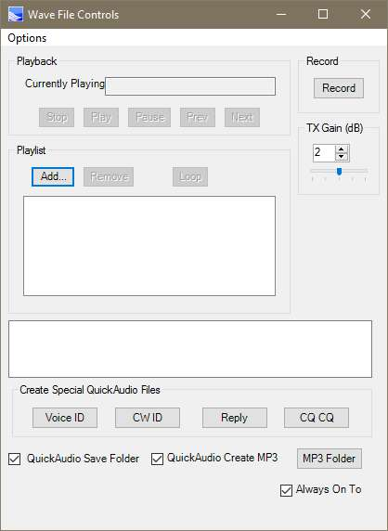

**NOTE:** All these recordings record using the current audio settings (MIC, DX, CPDR, DEXP, and TX filters). During Playback all the audio settings for the MIC are bypassed (except for your TX filter).

**“Memory” button (top of PSDR console screen):**- Drag & Drop hyperlinking, places URL into the Comments section of a memory. Right Click on memory to open up URL. Also works with files as well. You can manually add a URL directly into the comment field.  
Example: <http://ke9ns.com/flexpage.html>  
Note: Drag & Drop will not work if PowerSDR launched in ADMIN mode. ADMIN mode is needed if you wish to use the TIME SYNC function in the DX Spotter screen.  
- Open a Hyperlink: Select a Memory Row (single Left Click on any memory row), then Right Click.  
- When PSDR is in Focus, Hit ALT + M key to add current Freq, Mode, Filter on your Panadapter to Memory list  
- Weekly or Monthly recording schedule.   
- Schedule recording, records MP3 file to save space with long recordings. Example: A radio drama from the AM Broadcast band, or a Group Net.  
- Memories appear in Panadapter, when Spotter menu screen “Memories to Pan” box checked.

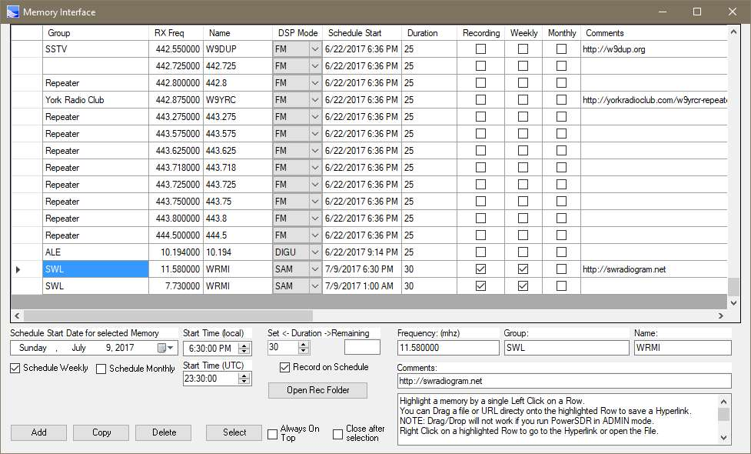

You can now enter in a Start Time (for changing frequencies and/or recordings on a time schedule), in either Local Time or UTC time. (i.e. Enter in a Local time, and you will see the UTC time below. Or Enter in a UTC time and it will show the equivalent local time above it)

**“TX WaterID” button and Callsign box (top of PSDR console screen):**Type your callsign into the box (keep the mouse inside the box while typing). Move mouse out of box and wait for box to turn GREEN. Hit the “TX WaterID” button to transmit your text into the waterfall. Other SDR radios with waterfall will see your text in their waterfall.  
- Option to transmit WaterID was wide as your current TX settings (see **Setup->Transmit->Wider WaterID**)  
- Right Click on callsign box to open up folder to drop your 100 pixels wide x 100 to 200 pixels tall x 24bit BMP files if you want to transmit BMP images. Type the name of the BMP in the callsign box (example IDIMG1.bmp so you type: IDIMG1. Leave off the BMP). BMP images are inverted: Black areas of a BMP are Bright in the water.  
- Turn OFF Waterfall Averaging by turning off the “Avg” button, or set it to “**AvgP**“ . This is mandatory on both transmit and receive of waterfall images.   
- Make sure the Panadapter/Waterfall width is not set too wide. Too wide, and the waterfall image will be very tiny.  
- Left Click on the “**Auto Wtr/Pan Lvl**” button (while Transmitting and receiving) to get the best image clarity in the waterfall.  
  
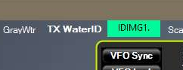 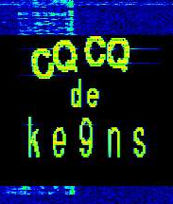 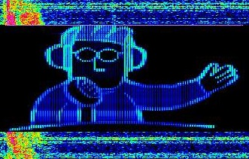

**“GrayWtr” button (top of PSDR console screen):  
Toggles the waterfall between color and grayscale. Grayscale shows finer details better (like the TX WaterID image.**  
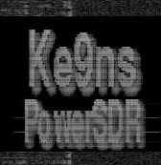

**“Scanner” button** **(top of PSDR console screen):**Display will output the Current Squelch level, and highest signal level, and any remarks  
The **Squelch pause Length** time is how long the Pause will last on a Squelch break (0=forever)

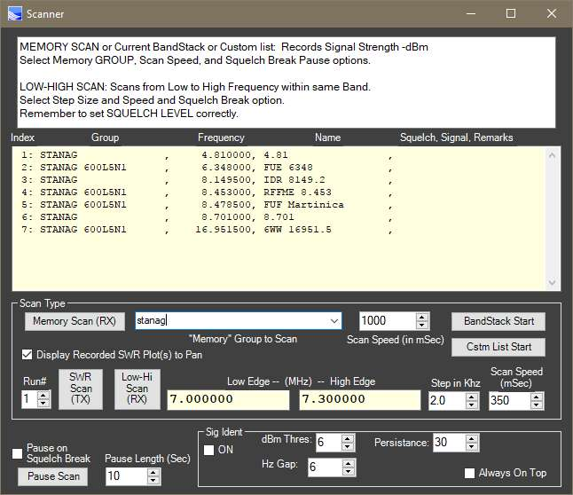

**Memory Scanner:**  
Select a “**GROUP**” of your available Memories to Scan, from the drop down list. (or a partial Group name)   
Then Select a scanning speed and optionally if you want to pause on a Squelch Break.  
Hit the **Memory Start** Button (to Start and Stop the Scan). Green when its running.  
Example: Type in a GROUP name of: **Nets**   
This will scan all **MEMORIES** that contain the word **NETS** in its **GROUP** name (it ignores case)  
  
**BandStack Scanner:**   
Go to the Band you want to Scan in.  
Hit the **BandStack Start** button to start a scan of the current BandStack memories  
  
**Custom List Scanner:**   
Click on the “**Cstm List Start**” button. This is the Folder to create and drop your text files (any name you wish)  
Select the Name of the File that contains the List of custom memories to scan (up to 50) and Click **OPEN**  
Custom Memory File Text formated as: **NAME**, **FREQUENCY** (in Mhz) , **MODE**, **FILTER**  
Example: **IARU Beacon,14.200,USB,F3**  
FILTER names: F1,F2,F3,F4,F5,F6,F7,F8,F9,F10,VAR1,VAR2 (F1 being the Upper left button)  
MODE names: LSB,USB,DSB,CWL,CWU,FM,AM,DIGU,SPEC,DIGL,SAM,DRM  
Hit the **Cstm List Start** button, and select the file name.

**Low-High Scanner:**  
Go to the Band you want to Scan in.  
The Low and High end of this band will automatically populate the Low Edge and High Edge Frequencies.  
You can optionally override the Low and High edges.  
You can optionally set to Squelch level which will pause the scan when broken.  
Hit the **Low-High Start** button to start the scan. Hit it again to restart the scan.

**SWR “Scanner” button** **(top of PSDR console screen):**

NOTE: For the Flex-3000 and Flex-5000 only.  
The SWR Scanner feature records up to 5 separate scans per band, per ant input.  
(Top image) In Panadapter Display mode, up to 5 Run#’s are displayed for a particular Band and Ant input.  
(Bot image) In PanaFall Display mode, 1 scan of 5 possible Run’s is displayed on the screen.

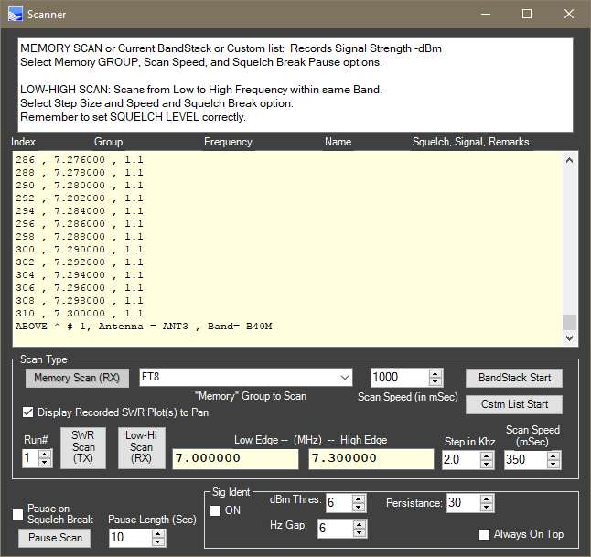

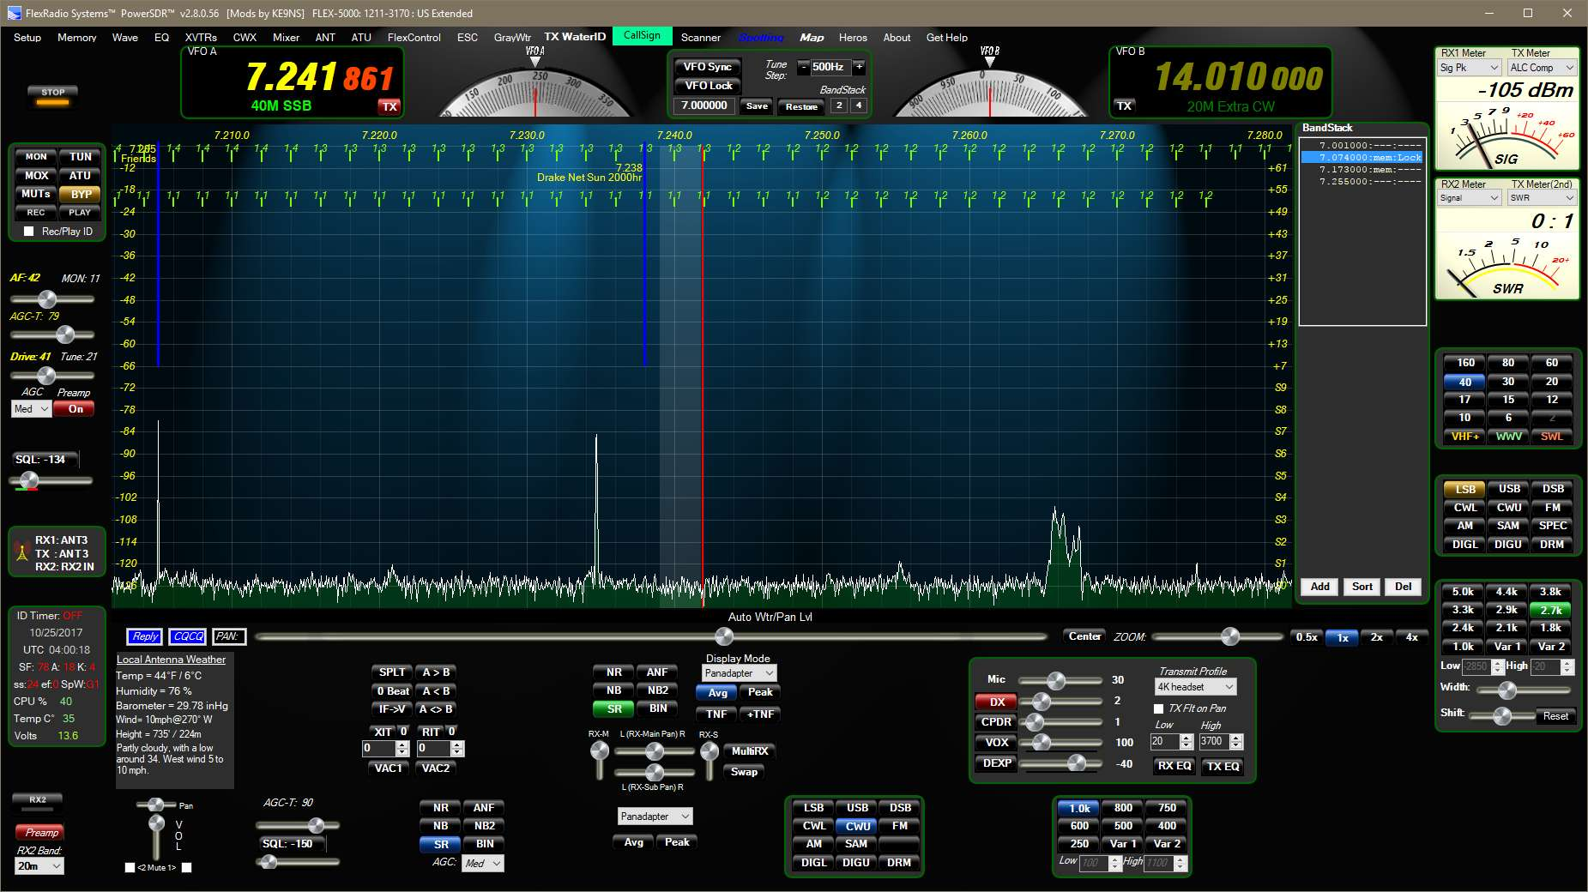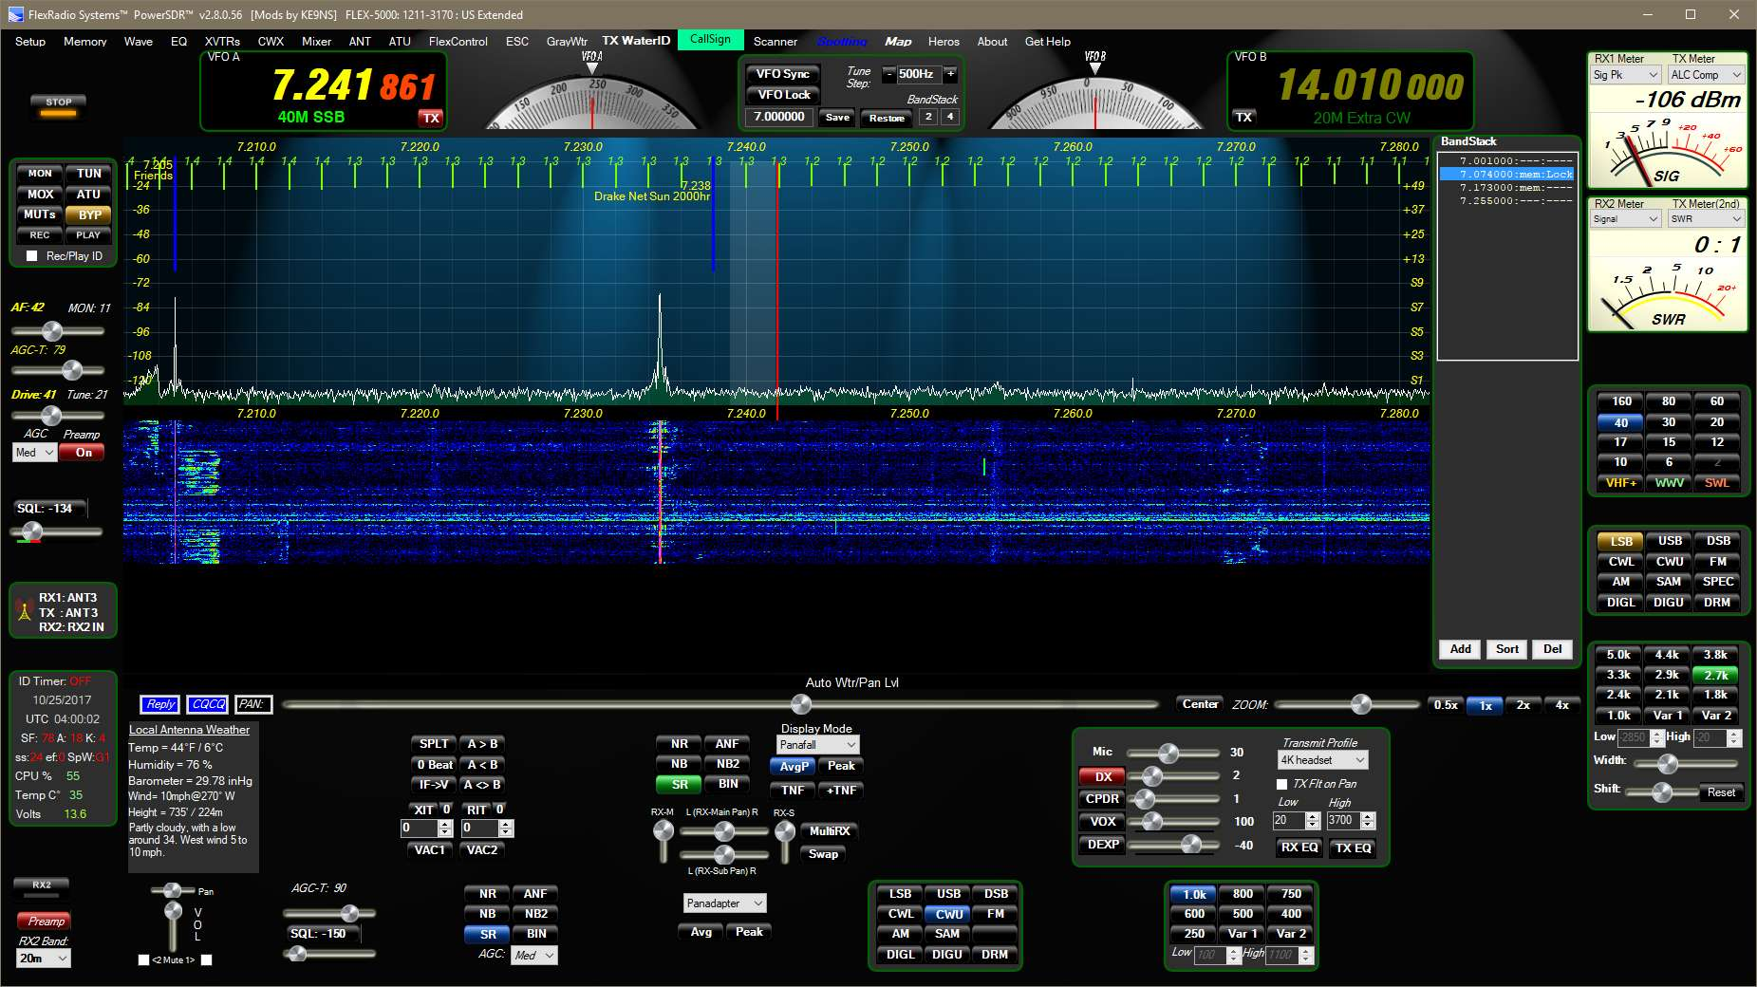

**SWR SCAN (TX) button:  
  
SWR SCAN:**During the Scan, the radio will use the TUN function and set the output level to “10”.  
1) Select your **Band**. Select your **ANT** (Flex-5000). Select the RUN# (1 through 5). The RUN# can be thought of as a trial# (as you trim your antenna and take a new SWR scan of the band).  
2) Select the **Scan Step** in KHZ (1,2,3,4). Select the **Scan speed** (> 250mSec for stable SWR readings).  
3) Select the **Low & High Freq** Edge(s) of the Scan (Note: Low/High must fall within the normal band limits). Make sure you see the trailing 0's after you click on the field to make sure the new value is accepted by the program.  
4) Click on the **SWR Scan (TX)** button.  
Click on the SWR Scan (TX) button at any time to STOP the scan. Click again to continue where you left off.  
a) If you click on the Low or High Freq Edges, the Scan will Staring position will reset to the Low Edge.  
b) A new scan will only overwrite data as is scans. It will not wipe out prior data.  
c) The data is stored when you close PowerSDR or Setup->Save, in a file ke9ns_SWR1.dat (which you can delete). Right Click on the TX WaterID callsign box to open the folder with the file.  
  
**SWR Display:**1) Click on the “Display Recorded SWR Plot(s) to Pan” checkbox to display.  
2) Click and select a number 1-5 in the RUN# box.

**PowerSDR KE9NS Console Screen:  
  
Map” button (top of PSDR console screen):**Shortcut to directly turn on World Map found in Spotter menu screen.  
  
**“About” button** **(top of PSDR console screen):**  
Links to PDF’s and videos explaining the features

**PowerSDR Console Information Details (very top of PSDR console screen):**- Now displays the TURF Region programmed into your Flex Radio  
- Contact Flex Radio if you need to change your Radios Region (TURF)  
(Turf is the Region your Flex Radio is programmed for. Example: Europe, US, UK, etc.)  
  


Note: My radio’s Turf is listed as “US”

**IARU Region1 60m transmit addition:**- Firmware update to allow Region 1 60m transmit  
- Update to “Europe” turf with new Region 1 60m Band plan and Band text

**BandStack (index & size) buttons (top of PSDR console screen):**- Left Click on either Bandstack Index or Size indicators to open up free standing BandStack window.  
- Right Click on either Bandstack Index or Size indicators to open Bandstack window embedded into panadpater window.  
- ADD, SORT, and DEL buttons for up to 12 BandStack entries  
- Left Click on BandStack entry to go to Freq, Mode, Filter  
- Right Click on BandStack entry to ”LOCK” it (prevents changing or deleting)  
- “mem” indicates this BandStack is also in your “memory” list  
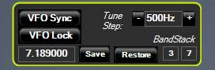 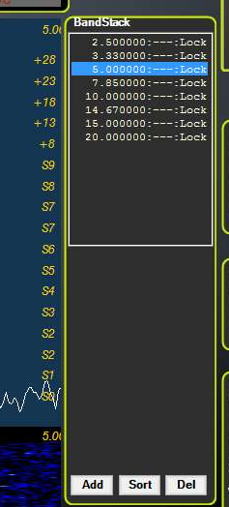

**PowerSDR KE9NS Console Screen (Continued):**

**VFOA/VFOB KHZ or MHZ frequency entry (top of PSDR console screen):**- you can now **enter KHZ frequency** for frequencies below 30mhz. (example: enter 3845 = 3.845mhz)  
- Larger Bold VFO Fonts (see Setup->Appearance->General->Bold or Outline Font)  
- Colored Rings around most off the Console Panels (see Setup->Appearance->General->Ring Color)

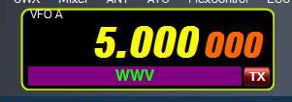 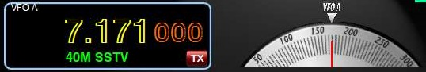

**Analog Meters (PSDR console screen):**- Left Click on RX1 meter to Toggle Between Meters: EDGE, TR7,Analog, Analog Light, Analog Dark  
- Right Click on RX1 meter to open up setup->Appearance->Meter  
- RX meter adds “Sig Pk” feature, this adds a 2nd Red Needle that hold the Peak S value for a few seconds.  
- TR7 meter option  
- 2nd TX meter “Combo”, allows for simultaneously viewing Power, SWR, ALC and live MIC levels  
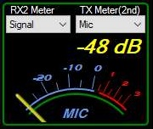 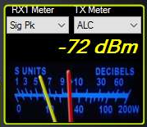 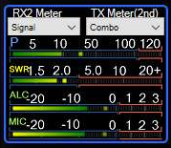   
 **Live MIC on 2nd Meter:**If you select MIC as the TX 2nd meter, it will be live if you are using a MIC attached to the Flex radio.  
(Note: Make sure VAC1 or VAC2 is not active to use Live Mic)  
 **Proper S9 Readings for HF and VHF/UHF bands**  
-73 dBm = S9 for HF bands up to 30mhz  
-93 dBm = S9 for VHF/UHF bands

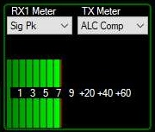

**2nd TX Meter (PSDR console screen):**  
- For all Flex radios, allows you to view 2 functions simultaneously   
- see Setup->Transmit-> TX 2nd meter active  
- Click on the 2nd Meter to move it UP under the 1st meter or down to the bottom **Auto Waterfall and Auto Panadapter adjustment Feature (PSDR console screen):**- Left Click on “**Auto Wtr/Pan Lvl**” button to adjust the Waterfall visual display  
- Right Click on the “**Auto Wtr/Pan Lvl**” button to adjust the Panadapter visual display  
- **Setup->Display->auto grid level** & **auto Wtr level** sliders to adjust bias points  
**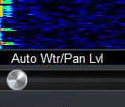  
  
MultiRX feature (PSDR console Screen):**  
- Now has the option of resetting back to VFOA when Toggled back OFF (see Setup->Display->MultiRX auto reset)

**Gridlines on the Panadater can be turned ON/OFF**- you can now turn off the Panadpater gridlines (see Setup->Display->Grid lines off

**Waterfall Move: Now the waterfall data moves with changes in Frequency (PSDR console screen):**  
- original PSDR waterfall did not move, so when you moved in frequency, the entire waterfall history was all invalid. This has now been fixed.  
- Black areas in the waterfall appear when you move frequency and there is no valid data in the waterfall.  
- **Setup->Display->Enable wider waterfall** (slightly more cpu but allows more sliding around frequency before needing to clear the waterfall data).  
  
**RX1 Mute checkbox (PSDR console screen):**-Allows you to mute RX1 audio while listening to RX2 audio  
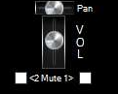

**MON button (PSDR console screen):**  
- Monitor function now works in AM/FM modes (MONpr only)  
- Click to Toggle between **MONps** (Post Processed: You hear what is transmitted by your radio), and **MONpr** (Pre Processed: You hear what is going into the Radio)

**TUN button and PULSER TUNE function (PSDR console screen):**  
- Right Click to Toggle between **TUN** (standard CW carrier TUNE), and **TUNp**  
- **TUNp** is Pulser Tune (see setup->transmit->Pulser tune->P/Sec = pulse per second  
Duty%=the off to on %amount)  
  
**MUT button and MUTE speakers only function (PSDR console screen):**  
- Right Click to Toggle between **MUT** (mute speakers and headphones), and **MUTs** (mute just speakers and not headphones).  
- Left Click to Toggle the MUT/MUTs ON/OFF  
  
**“Rec/Play ID” checkbox for MIC recordings (PSDR console screen):**- When Checked, allows you to record your MIC audio whenever you Click the “REC” button.   
- The “PLAY” button will key the transmitter and play the last recorded file.   
- If you Right Click on the “PLAY” button, you will see the list of your recorded QuickAudio files, you can manually select any file and Click OPEN. Now the “PLAY” button will play that selected file. Right Click on “PLAY” button and hit CANCEL, to go back to playing the last recorded file.  
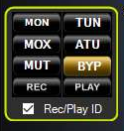  
**AF / MON slider(PSDR console screen):**- AF and MON always show current values  
- Click on “AF” or “MON” text to change function of slider

**Drive / Tune slider(PSDR console screen):**- Drive and Tune always show current values  
- Click on Drive or Tune text to change function of slider  
- Right Click on “Drive” text to toggle LOCK the Drive and Tune output values  
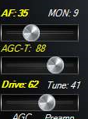

**Antenna panel (PSDR console screen left side):**  
- Added ANT icon  
- Click on panel to open up ANT selector screen (varies by Flex Model)  
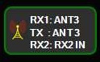

**SWL Band buttons (PSDR console screen):**- Individual 14 SWL band buttons, each with their own BandStack.   
- Bands: L/MW,120m,90m,61m,49m,41m,31m,25m,22m,19m,16m,14m,13m,11m  
- See **SWL Spotting with searchable listing window (above) for SWL search lists**

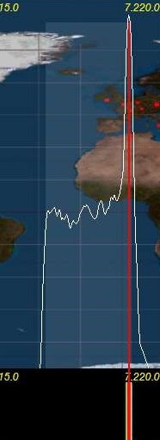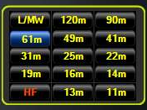

**Operating MODE (PSDR console screen):**- Drag AM passband across the Carrier line and RX switches to SSB, but TX stays in AM mode.  
- Left Click on **AM** button to toggle between (H3E) **AM-L**, **AM-U**, and AM  
- Left Click on **SAM** (Synchronous Receive) button to toggle between (H3E) **SAM-L**, **SM-U**, and SAM  
Normally AM & SAM transmit is DSB with a full Carrier. AM-L or AM-U is SSB with a Full Carrier.   
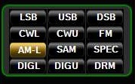

**Space Weather data (PSDR console screen):**- Click to Toggle On/Off  
- **ss:** Official Sun Spot# from sidc.oma.be updated hourly (determined by optical observation of the sun)  
- **ef:** Effective Sun Spot# from nwra.com updated hourly (determined by radio observation of mid latitudes)  
- Space weather indices: SFI, A, K, and storm data from NOAA.com  
  
**Local Weather data (For North America only) (PSDR console screen):**  
- Click on **Space Weather** a second time to toggle **Local Weather** at your Transmitter sight. This is based on the Lat and Long values you used in the DX “Spotter” screen (lower Right corner of the Spotter window)  
- Local weather will only appear if there is enough room on screen for it to fit (if PSDR is open wide enough).  
- Click on the Local Weather to turn it OFF.

**Temp & Volts (PSDR console screen):**- Model Flex-3000 and Flex-5000 only  
- Click to Toggle On/Off (click on temp toggles between C and F)  
- Shows PA temp/volts (updates at same rate as CPU% found in setup->display) (varies by Flex model)  
- Local Weather

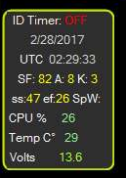

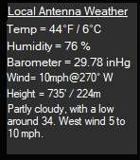

**ID Timer 10 minute (PSDR console screen):**  
- Left Click to Toggle ON (synced to next minute),  
- Left click again ON (synced to next 10 min increment 0,10,20,30,40,50), then one more click to OFF  
- Right Click to Toggle between: Pop-Up **Message box**, **WaterID**, **VoiceID**, **CWID** (see Wave screen for recording **VoiceID** and **CWID** audio files)  
- Pop-Up Message box has option for 5 second timeout, or stay on screen until you click on it to close.  
- Position of Message box is remembered so you can place it on a 2nd monitor  
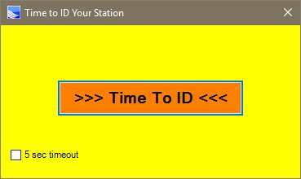  
  
**Time Out Timer (setup->General->Hardware Config->Time-Out Timer):**  
- Check to activate feature.  
- When Radio is transmitting the timer counts down to 0  
- If Count reaches 0, the Radio turns OFF and Pop-Up message box must be cleared.

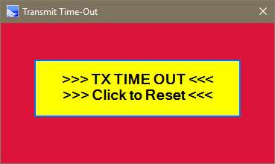

**PAN: VFOA Slider feature (PSDR console screen):**  
- Click PAN: button (turns RED) to Toggle VFOA Slide function, allows VFOA to slide around Panadapter screen while screen does not move.  
- To reset, turn off PAN (turns White), then click on “Center” button

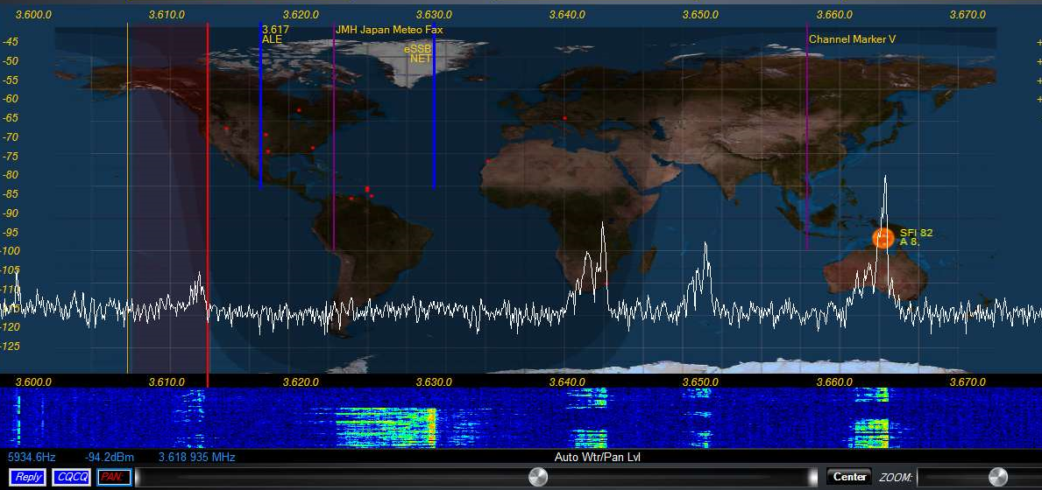

**ZOOM: feature (PSDR console screen):**  
- Left Click to Toggle Panadapter signal enlarger feature ON/OFF (Zoom in the vertical direction only)  
- Right Click to turn ON extra Panadapter window showing your BandPass area.  
 **Transmit Profile (PSDR console screen):**- Low / High transmit profile settings viewable from main console window  
- Right Click on current transmit profile to open up setup->transmit   
- TX profile selectable from the DIGU and DIGL panel  
 **Relay / CQCQ buttons (PSDR console screen):**  
- Click to automatically MOX your radio and transmit prerecorded audio files  
 (see Wave screen for recording Reply and CQCQ audio files)  
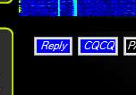  
 **RX2 PanaFall Mode (PSDR console screen):**- RX2 can now be viewed in Panafall mode, just like RX1  
 **RX1 Continuum waterfall Mode (PSDR console screen):**- Special waterfall screen that shows dBm vs time  
- Right click on “Continuum” to toggle recording a .CSV file (in the database folder)

**VAC1/VAC2 buttons (PSDR console screen):**  
- Right Click on panel to open up setup->Audio->VAC1/VAC2 panel directly

**NR/ANL/NB/TNF buttons (PSDR console screen):**  
- Right Click on panel to open up setup->DSP->Options panel directly  
- Reset button on the Options panel (if you mess up the settings)  
  
**CWX Panel:**- Added CW Key Polling option. Hit your CW key or paddle to stop any macro transmission  
- Larger Macro text size  
- Sync CW speed to CW panel on main PSDR console screen  
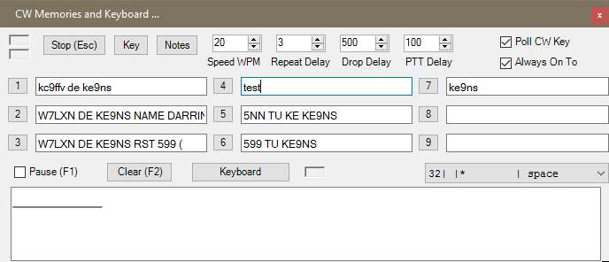  
  
**Flex Control Knob:**- Alternate Tune Step Rate FlexControl Knobs (see setup->General->User Interface)  
**PowerMate Knob:**- Built in PowerMate Knob driver  
- Alternate Tune Step Rate for both Powermate Knobs (see setup->General->User Interface)  
- Seperate Alt Tune Step ON checkbox for either PowerMate or FlexControl  
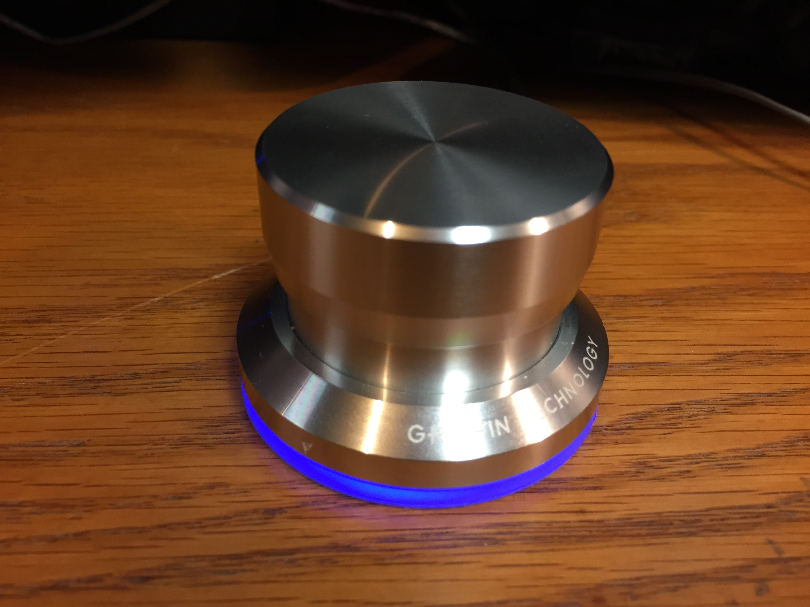  
  
**DJ Console:**  
- Incorporated DH1TW code for interfacing DJ Console controllers.  
- See setup->General->User Interface  
- Fixed A>B, B>A, A<>B functions  
  
**HTTP Server (see image below):**  
- Setup your Router “Port Forward” to pass the Port# you select.  
- get an No-IP.com account which is a permanent URL linked back to your home IP address  
- setup your router to update your No-Ip.com account (usually under apps and gaming)  
- Now if you type in your no-ip.com URL:port# from a web browser you will see your Panadapter  
- Full Console: when checked, will show the Entire PowerSDR console over the internet (including any open windows sitting on top of the PowerSDR console)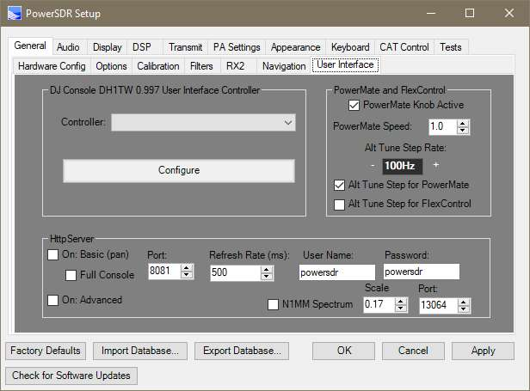  
  
**Output Panadapter to N1MM+ logger Spectrum window (setup->General->User Interface->N1MM)**  
- The only caveat is that the PowerSDR Panadapter or Panafall screen needs to be up and running in order for it to provide data to N1MM+ spectrum screen.  
- Right Click on the N1MM spectrum screen and select your callsign as the data stream.  
- N1MM displays spots on this window.  
- When N1MM properly configured, clicking on this screen will change the TX/RX freq of PowerSDR.  
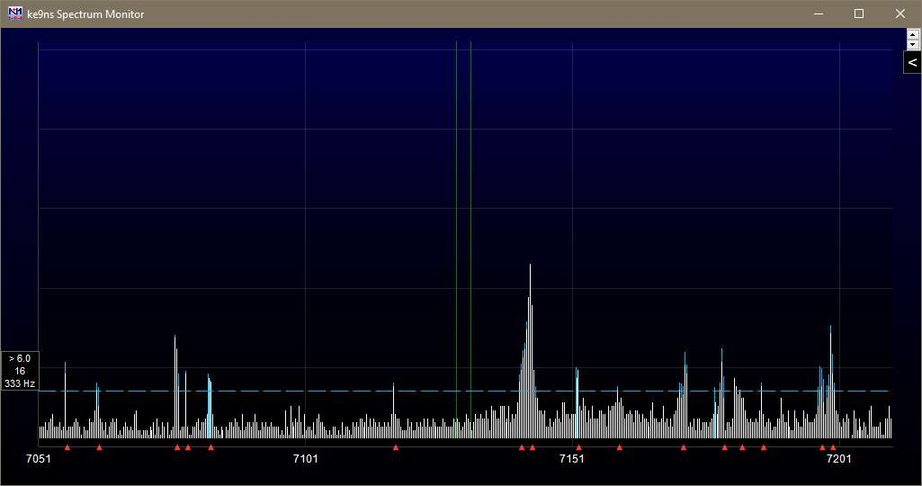

**BandText Data:**

Right Click on VFOA BandText to Toggle BandText ON/OFF in the Panadapter area.  
Under **Setup->General->Options**   
Click **Update BandText** button to grab the current default PowerSDR BandText data and update your current Database file. Recently added FT8 and JT65 BandText for the HF/6M bands.  
Check the “**Reset/Update Band Stack**” box if you want to also reset your BandStack at the same time as your BandText.